

Run Book: End of Day (EOD)

Contents

**No table of contents entries found.**

# Key information

## IP Addresses

|  |  |  |  |
| --- | --- | --- | --- |
|  | **Env** | **IP** | **Service** |
| DW Server | UAT | ICBFSBRUDW19 10.1.10.13 | ICBFS_UAT_GUI_User |
| Prod |  | sa_? |
| DR |  | sa_? |
| NDM Server | UAT | ICBCFSBRUBPSADB **22.33.51.107** | (personal) |
| Prod |  |  |
| DR |  |  |
| Trade Database | UAT | ICBCBRFSBRUTR19 - 10.1.10.15 | (personal) |
| Prod |  |  |
| DR |  |  |
| Shared Drive | UAT | \\icbcfscad31\UATSFTP\icbc_fs_br\IMPACT\ICBUAT | (personal) |
| Prod |  |  |
| DR |  |  |
| NDM File Location | UAT | E:\DATA\IMPACT\Download\ | (personal) |
| Prod |  |  |
| DR |  |  |
| Portal URL | UAT | <http://10.1.10.5:9000/Internal/EODStatus> | (personal) |
| Prod |  |  |
| DR |  |  |

# EOD Checklist

|  |  |  |  |
| --- | --- | --- | --- |
| **Step** | **Time** | **UAT** | **Prod** |
| DW Admin log entry status | 2:30am | □ | □ |
| FIX Heartbeat messages occurring | 6-7am EST | □ | □ |
| MSMQ up | 6-7am EST | □ | □ |

# EOD Checklist Instructions

Step 1: Operator to check DW Admin Log Entry Status **(DW Server)**

Task: Run the query *SELECT * FROM dw.admin.EOD_log*

Action: Ensure that the entry status is "started" for today's date. The entry is blank right now but when EOD is started there should be an entry on the table.    
   
 

Step 2: Verify NDM File Arrival **(NDM Server)**

Task: Check if all 29 NDM files have arrived from Broadridge every night at a specific location. If files are not at the designated location, Contact Broadridge team to resend the files.

Action:

1. Verify the NDM files at the designated location. once you receive all the NDM (UAT)files

E:\DATA\IMPACT\Download\

This is an automated process that runs every day from 11 PM to 11:59 PM. Broadridge runs the process via the Z-Centric server. This processed is owned by Broadridge.

1. Click Start on job copy_ndm_files on NDM Server sql server
2. 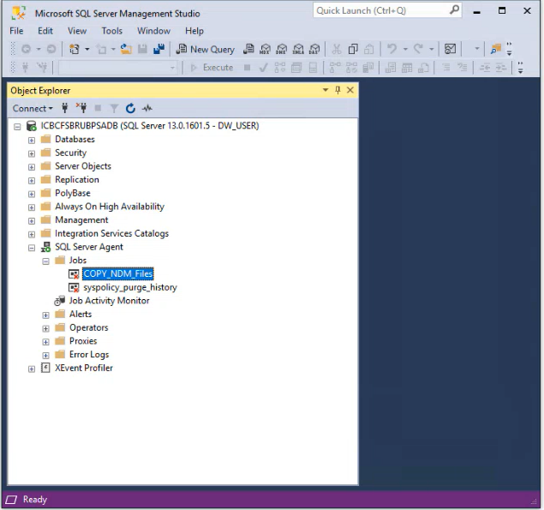

   
 

Step 3: Trade Database

Task: This is an automated process that runs every day from 11 PM to 6 AM

To start COPY_NDM_TO_LOCAL on DW1 for file transfer. This will move the files from the E:\Data\Impact\Download to  \\icbcfslcad31\UATSFTP\icbc_fs_br\IMPACT\ICBUAT\Archive

Action: Operator to click Start on job COPY_ NDM_TO_LOCAL  (copy files to Archive folder)

\\icbcfslcad31\UATSFTP\icbc_fs_br\IMPACT\ICBUAT\Archive What is this?

## Step 4: Confirm File Copy Completion

Task: Ensure that all NDM files are successfully copied to the destination.

Action: Check if the NDM files are present at the location:

\\icbcfslcad31\UATSFTP\icbc_fs_br\IMPACT\ICBUAT   
 

## Step 5:  NDM Files Loading from Stored Procedure (Runs Sequentially)

Task: This is an automated process that runs every day from 11 PM to 6 AM Action: Operator to click Start on job load_NDM_files_to_staging.  10.1.10.15   
\\icbcfslcad31\UATSFTP\icbc_fs_br\IMPACT\ICBUAT\Archive  Where do you get that?

Step 6: NDM Files Loading from Package (Runs Concurrently) **(10.1.10.13**

Task: These jobs automatically start(Load_NDM_BECDLDEP, Load_NDM_CUSDLDEP, Load_NDM_EX2FILEP ,Load_NDM_FINDLDEP, Load_NDM_KKSDLDEP, Load_NDM_T9PDLDEP, Load_NDM_XGLDLDEP, Load_NDM_XPDLDEP, Load_NDM_YAPDLDEP) to load files from package.

In the 10.1.10.13

This is an automated process that runs every day from 12 PM to 11:59 AM. This is in the jobs on the 10.1.10.13 server.

Make sure the files are in the archive folder otherwise it won’t load the database. Below runs   
\\icbcfslcad31\UATSFTP\icbc_fs_br\IMPACT\ICBUAT\Archive 

 

Step 7: Recursive Jobs automatically Start **(10.1.10.13)**

Task: Make sure the jobs (Recursive IREP EOD & Recursive BPSA EOD) are running automatically from the scheduler.    
"This is an automated process that runs every day from 8 PM to 9 AM."    


In the SQL Agent Jobs

Step 8: Check ERROR LOG  --Operator manually Run every 10 minutes until the all above jobs done. He waits for the green button on the UI is how we know that it is done. Operator to check if we have an Error Message Run Below query on DW-2   
select * from dw.admin.ErrorLog

select * from staging.dbo.staging_lod_log_error

select * from staging.admin.SP_error

Operators should investigate any pending issues, in the case of non-resolvable issue, should escalate to Level two. If an error is message is seen, then there was an error loading. The SSIS package should ensure that the rows match.

## Step 9: Operator should wait for BPSA files received from Broadridge at 12AM.

BPSA files should be received from Broadridge at 12AM.  First the iRep files come and then BPSA files come. Thus, you will see a similar process but one is BPSA and one is iRep.

The job (Recursive IREP EOD & Recursive BPSA EOD) should automatically implement once the BPSA files arrive.

## Step 10: Verify Category Load Status

Task: Operator to check the category load status to ensure all files are loaded. No matter the color of the button on the screen, we have to check this.

Keep in mind we are looking for two things

1. There are these 125 rows
2. All the buttons are green.

Action:

1. Operator to run this query Below

*SELECT * FROM CATEGORY_LOAD_STATUS WHERE ASOF_BUSINESS_DATE = '2024-01-01'* in the IREP_DB database.

To check if there are 125 rows from the category table, if less, have to wait until the job is completed, or maybe there is an issue.

1. To check all NDM files (Categories) are displayed in this table.  This happens every 20 minutes until complete.

## Step 11: 1. Operator to validate System Date on Both Servers as Completion Check

Task: Confirm the system date on both DW1 and DW2 servers.

Action: Check the system date using the queries:

* SELECT *\** FROM *config.dbo.System_Date —* DW2 Server
* SELECT * FROM dw.admin. Eod_status Where DWSystemDate=’2024-10-25’
* SELECT * FROM Irep_DB.dbo.System_Date (should be today’s date 2024-10-25)

*select * from Irep_DB.dbo.System_Date —* DW1 Server 

 The dates should just the last business day. So in this case, you were running the night of Oct 25th. This was seen at ~ 1am on Oct 26th

## Step 12: Initiate Report Generation Job Automatically

Task: After completing EOD and system date changed, it would automatically kick off the report generation job. New_Report_Generation in 10.1.10.15 server. This happens automatically every 10 seconds.

Step 13: DW Portal Check:   
Process: Access the DW Portal to monitor file statuses.    
Portal Link: EOD Status Portal (<http://10.1.10.5:9000/Internal/EODStatus>)

Purpose: Track the progress of file processing and identify any pending or running tasks.   
   
   
**Sample of File Status after DW Portal Check:**

